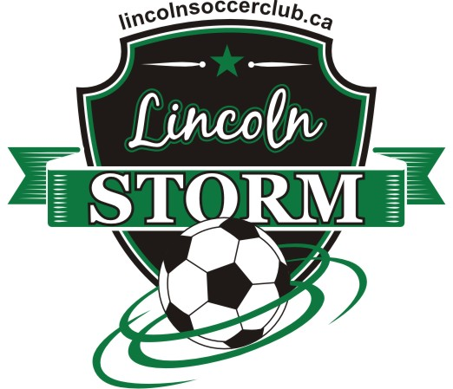

Once again it is that time of year for the Lincoln Soccer Club to ask local businesses to consider sponsoring a team for the upcoming 2017 season. By sponsoring a team, your company will receive advertising benefits, as well as the satisfaction of knowing that you are making a difference in the community.

Lincoln Soccer Club has been providing the local community for over 40 years with almost 1000 children benefiting from this program. Your sponsorship shows the community that you are helping the youth to maintain active and enjoy friendships.

You may sponsor your own child’s team or a specific division of your choice. Just fill the attached form (must send in), return it with a cheque and your logo on a 8 ½ x 11 paper. Your company logo will be placed on the jerseys. We ask that you submit your forms right away as spots fill up and we want to ensure your requests are made possible.

Team schedules can be found on the wnisl.com website.

The costs are per season at a rate of…

HOUSE LEAGUE
$400 for NEW companies sponsoring
$350 for REPEAT companies sponsoring (2017)

TRAVEL LEAGUE
$500 for NEW companies sponsoring
$450 for REPEAT companies sponsoring (2017)

Sponsor our Website: www.lincolnsoccerclub.ca

The Website is our communication to the community that provides schedules along with information for our coaching staff bulletins on soccer camps and tournaments. As we build this site, we are hoping to develop programs that will allow all levels to benefit.

$ 350 – you company logo can be posted on the website home page. It can also link back to your website.

Cheques are payable to LINCOLN SOCCER CLUB. You may postdate the cheques, but no later than February 28th, 2018.

Questions should be directed to Kathryn via email at lincolnsoccer@cogeco.ca

On behalf of the Lincoln Soccer Club and all the players, THANK YOU, and we hope to see you at the games.

Sincerely,
Kathryn Berube

Kathryn Berube
Administrative Secretary, LSC

